Across the U.S., 5G Runs Into Local Resistance
By Drew FitzGerald
Residents of Denver's Riviera apartments were surprised earlier this year when a roughly 30-foot-tall green pole appeared a few feet in front of their building entrance. The pole, installed by Verizon Communications Inc. and laden with cellular antennas, was designed to improve cellphone service in the area, but the residents complained about the placement.
Months later, it was gone. But that was just a small taste of what's to come across the country: Millions of Americans will soon encounter similar poles or notice antennas sprouting on existing structures, like utility poles, street lamps and traffic lights, all over their neighborhoods. All four national cellphone companies are pushing to build out their networks with a profusion of small, local cells to keep their data-hungry customers satisfied and lay the groundwork for fifth-generation, or 5G, service.
Those plans face pushback in many places, and not just from residents. Officials in some cities say they don't have enough staff to process applications for dozens or even hundreds of new installations. In some smaller towns, officials say they lack the expertise to review the new technology, though they're working fast to get up to speed. In Wilton Manors, Fla., Mayor Gary Resnick says the Miami suburb needs more time to draft an ordinance to govern the installation of the new technology. And there are seasonal issues. "We generally restrict construction in the rights of way during hurricane season for obvious reasons," he says.
Just around the corner
More than 100,000 small cells are already wired up across the U.S., according to industry research firm S&P Global. Cellphone companies plan to boost their capacity with several hundred thousand more cells to improve existing service and prepare for 5G service, which they see as a potential competitor for cable and fiber optics, among other things. Some of the local resistance is rooted in how small cells work. Companies can usually find space on private property for large cell towers with a range of several miles. Small cells reach only a few hundred feet, so carriers need many more sites, usually on public land, for the system to work.
Cellphone companies don't have much choice if they want to keep up with their customers' appetite for data, says Jonathan Adelstein, chief executive of the Wireless Infrastructure Association, whose members include wireless carriers. "People wonder why they might be having a dropped call or slow video," Mr. Adelstein says. "Then they have a vocal minority that are ruining it for everybody" by opposing the expansion of cellular networks.
Denver resident Brad Cameron says a new two-story pole that sprang up near his condo last winter "clearly has improved my cell service." But he wants to keep new poles to a minimum by making cellphone companies share space on the same structures. "The concern I've got is that instead of trees, we're looking at a forest of small cell towers," he says.
Denver City Council member Wayne New says the government is encouraging carriers to cooperate with the local electric utility to use more existing street poles.

Small Packages, Big Impact

Conventional cell towers will provide 5G service in many places, but they can't do it all by themselves, especially in cities. That's where small cells come in.

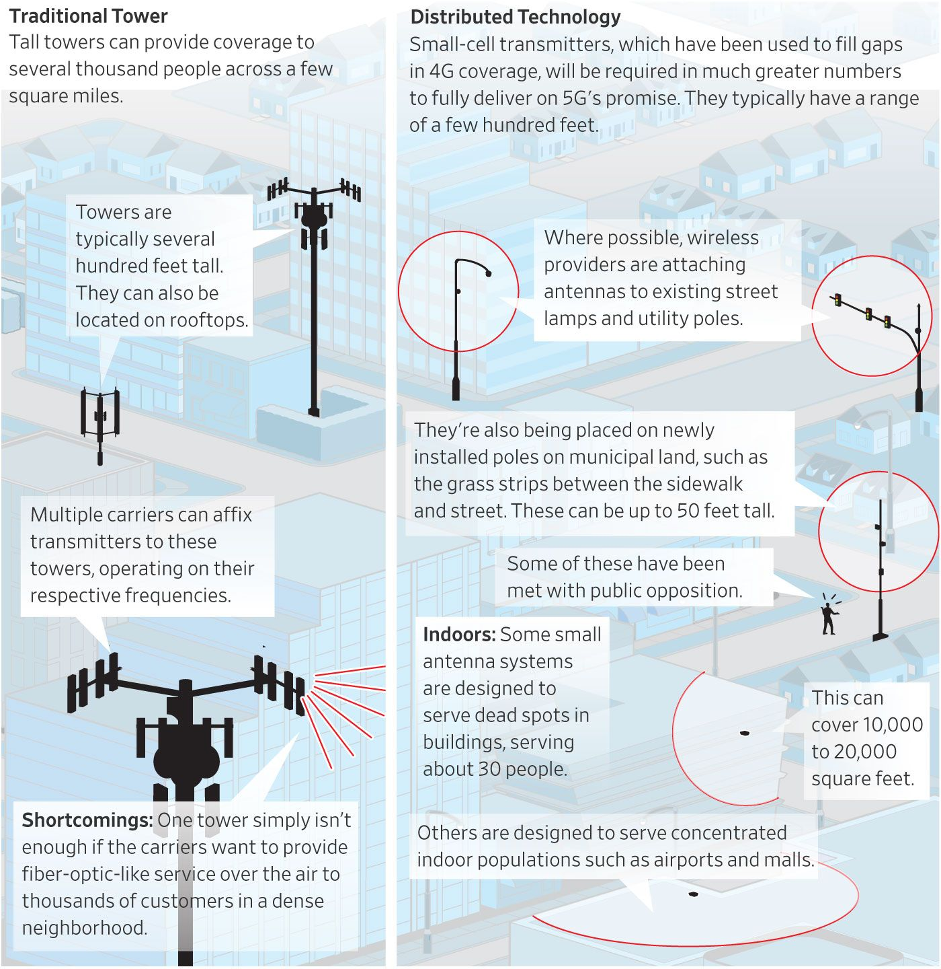
Policy battles
State and federal policy makers are mostly backing the wireless carriers. Federal Communications Commission rules passed in March exempt small-cell deployments from certain historic-preservation and environmental reviews. Another FCC rule slated for a vote this month seeks to lower local fees and would set 60-day or 90-day limits for local governments act on permit applications. A bill in Congress would deem small-cell applications granted if local governments fail to act on a request within 31 days. Dozens of state laws also restrict local governments' control over small-cell projects.
"It's all gamesmanship right now," says Angela Stacy, vice president at consultant SmartWorks Partners LLC, who advises local governments on telecommunications policy. "The carriers have basically launched a three-pronged attack" with the support of regulators and federal and state legislators.
Officials in San Jose, Calif., have tried to parry that offensive by fast-tracking installations for carriers that have agreed to help fund a local internet-access initiative. The Silicon Valley city has licensed space on light poles for a few hundred dollars per installation, using the money to connect low-income residents to high-speed broadband at home. AT&T and Verizon have signed on to the plan and are gearing up to install equipment.
"We tried to prove to the telecom industry that cities are not the problem," San Jose Mayor Sam Liccardo says. "We appreciate the industry's position that too much red tape can get in the way."
At the same time, though, Mr. Liccardo says the city and its allies are "battling the industry mightily" on the federal and state level, lobbying to block policies they consider a handout to cellphone companies because they would limit the fees the carriers can be charged to install and operate small cells.
"These poles are increasingly becoming valuable real estate," he says. "If cities can't manage their own infrastructure -- that their taxpayers paid to install -- it puts them at a considerable disadvantage."
AT&T strategic-planning executive Jason Porter says cities' needs vary but the company's experience with San Jose is a "win-win."
"Every concern that a city manager has is a viable concern," Mr. Porter says. "San Jose's a good example of a location that we've been able to work with."
Making adjustments
Other local officials say the installations could widen the digital divide between well-connected residents and those with limited service. In Maryland's Montgomery County, which covers rural communities and several suburbs of Washington, D.C., county planners are working on a fee structure for small cells. They want rental rates to vary depending on population density to encourage more rural deployment.
But in general, such fees take away from construction that ultimately benefits the public, says Rudy Reyes, a vice president of public policy for Verizon. "Capital budgets are limited, and we would rather use that money to invest in infrastructure and investment for our customers," he says.
Construction isn't slowing down in Denver, home of the since-removed pole in front of the Riviera apartments. The city now has nearly 100 small cells, with more than 250 additional installations planned. But the local government has set new guidelines to control where companies place their small cells, which prompted Verizon to take down a handful that it had already installed.
"They were willing to adjust to be good neighbors," says Jon Reynolds, a program manager for Denver's public-works department.
Verizon's Mr. Reyes says Denver has been an overall success so far. "We try to work with these residents to address legitimate concerns," he says.
Mr. FitzGerald is a reporter for The Wall Street Journal in Washington. Email him at andrew.fitzgerald@wsj.com.

(END) Dow Jones Newswires
September 13, 2018 16:12 ET (20:12 GMT)
Copyright (c) 2018 Dow Jones & Company, Inc.

